ACCOMPLISHMENT REPORT
IT 205 & 205L –Geographic Information Systems
Month: November – Year: 2025
School Year: 2025 – 2026 1st Semester

DATE | ACCOMPLISHMENT | REMARKS  (Progress and deviations from the plan) *
November 11 - 14, 2025 | Lecture Accomplishments:  - Reviewed the concept of spatial density and hot spots and connected it to real-world GIS applications such as disaster risk, crime mapping, and service accessibility.  - Explained in more detail the heat map parameters in QGIS (radius, kernel shape, weighting by attribute, and output resolution) and how each affects the resulting pattern.  - Discussed best practices in color ramps and legends for heat maps, emphasizing readability, perceptual balance, and ethical representation of intensity.  - Compared heat maps with choropleth maps, highlighting when each visualization type is more appropriate and how they can complement each other in analysis.  Laboratory Accomplishments:  - Guided students in tuning heat map settings (varying radius, weight fields, and quality) using prepared point datasets to observe changes in hotspot patterns.  - Required students to experiment with multiple color ramps and legend styles, then save different versions for comparison and reflection.  - Conducted a short practical exercise where students documented their chosen parameters and justified why those settings best communicated the spatial pattern.  - Provided initial feedback and corrections on parameter choices, ensuring outputs are technically sound and aligned with cartographic principles from Modules 1 and 2. | Accomplished  (Students deepened their understanding of heat map parameters and symbology; preparation for case-focused applications in succeeding weeks.)
November 17 - 20, 2025 | Lecture Accomplishments:  - Presented case-based scenarios (e.g., incident locations, service points, environmental observations) where heat maps can support planning and decision-making.  - Discussed how to combine heat maps with other layers (administrative boundaries, roads, land use) to provide context and support more nuanced interpretations.  - Emphasized critical interpretation of heat maps, including limitations (e.g., data quality, scale issues, over-generalization) and the importance of documenting assumptions.  - Linked Module 3 activities to course outcomes: designing thematic maps, executing basic GIS operations, and analyzing spatial patterns to solve real-world problems.  Laboratory Accomplishments:  - Assigned a mini case-study exercise where student groups selected a point dataset (e.g., accidents, facilities, or incidents) and generated an initial case-based heat map.  - Guided students in overlaying their heat maps with boundary layers and relevant thematic layers (e.g., population or land use) to enrich interpretation.  - Required each group to prepare a brief written interpretation of their heat map (hotspot locations, possible causes, and potential actions), aligning with research and problem-solving skills.  - Collected draft outputs and comments, clarifying that these are intermediate products that will be refined and finalized in December as part of the concluding Module 3 activities and term assessments. | Accomplished  (Initial case-based heat maps and layer integration were completed; final refinement and formal layouts are intentionally reserved for December.)
November 25 - 27, 2025 | Lecture Accomplishments:  - Reviewed layout and cartographic standards specifically for heat maps, including appropriate titles, legends, scale bars, explanatory notes, and data source citations.  - Discussed writing short analytical summaries to accompany heat maps, focusing on clear communication of findings and limitations to non-technical audiences.  - Provided a preview of December activities, including finalization of heat map layouts, case-study presentations, and term-end assessments (final exam and/or project-based outputs).  - Reiterated ethical and responsible use of geospatial data and maps, especially when displaying sensitive patterns such as crime or vulnerability.  Laboratory Accomplishments:  - Guided students in creating draft print layouts for their case-study heat maps (map frame, legend, scale, north arrow, annotations) using QGIS print layout tools.  - Conducted peer review and instructor feedback sessions, where students critiqued each other’s draft layouts based on clarity, aesthetics, and correctness.  - Required students to revise their layouts based on feedback and submit draft heat map outputs plus a short written interpretation as preliminary deliverables for Module 3.  - Organized and archived draft layouts and reflections as proof/evidence of November accomplishments, noting that final polished outputs and comprehensive case-study reports will be completed in December. | Accomplished  (Draft heat map layouts and written interpretations were produced; final refinement, presentations, and summative assessments for Module 3 are scheduled for December.)
*Provide relevant documentation such as pictures, summary reports, etc.

Prepared by: Approved:

JUNNIE RYH M. SUMACOT SHERWIN G. CADAY, PhD.
Instructor Program Chair

PROOF/EVIDENCE OF REPORTED ACCOMPLISHMENTS
IT 205 & 205L –Geographic Information Systems
Month: November – Year: 2025
School Year: 2025 – 2026 1st Semester
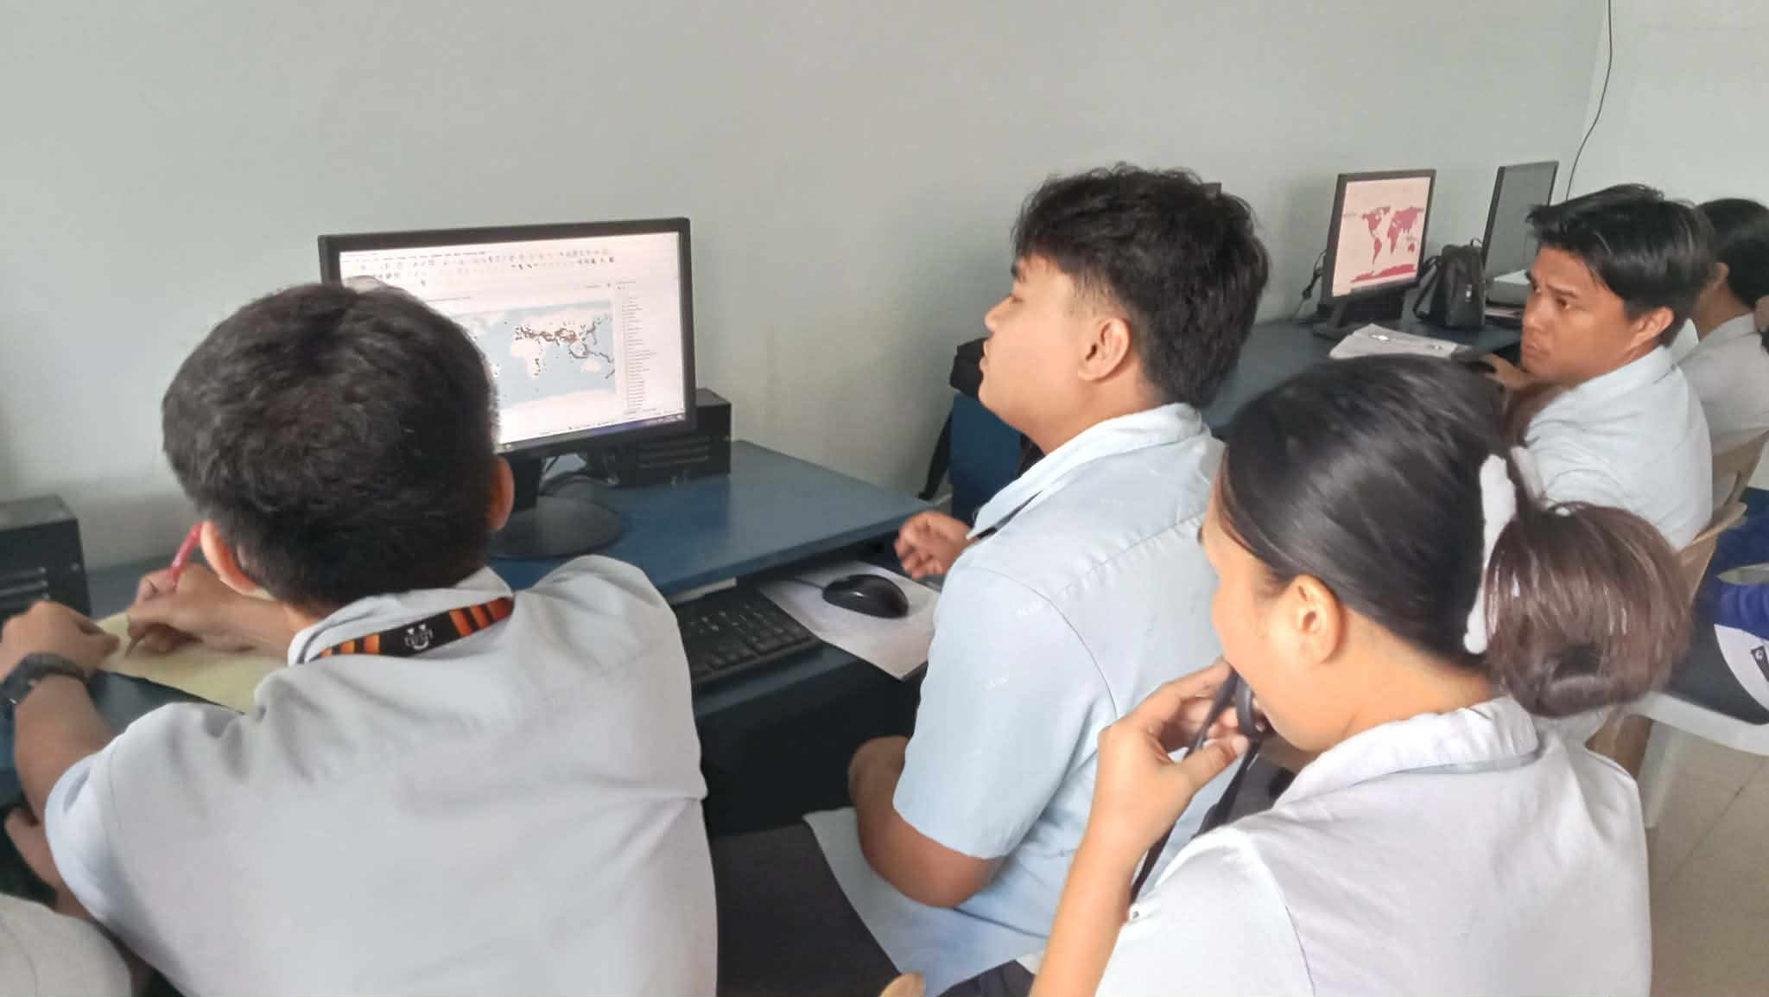
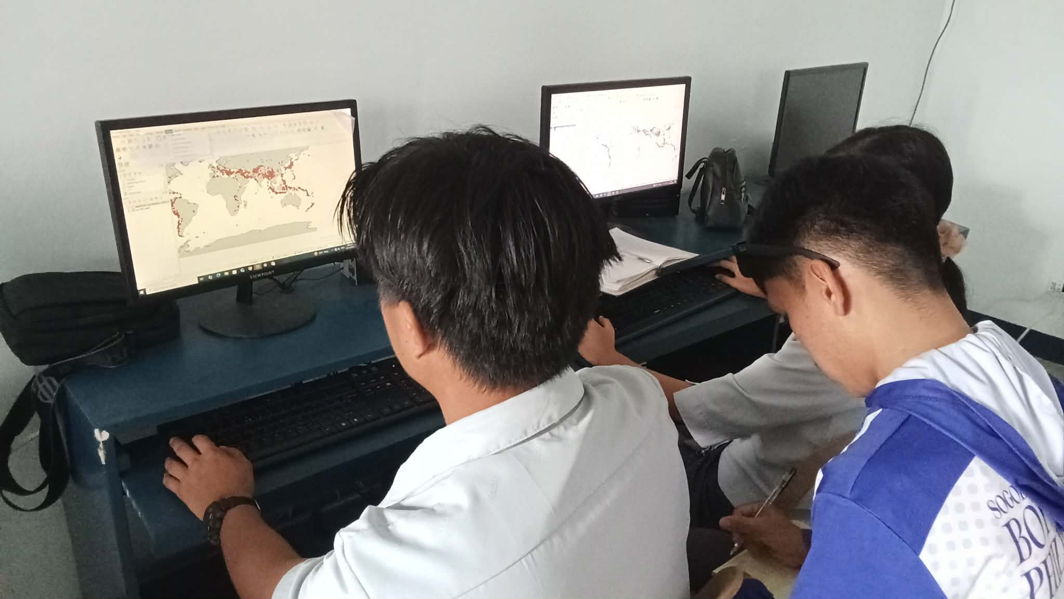

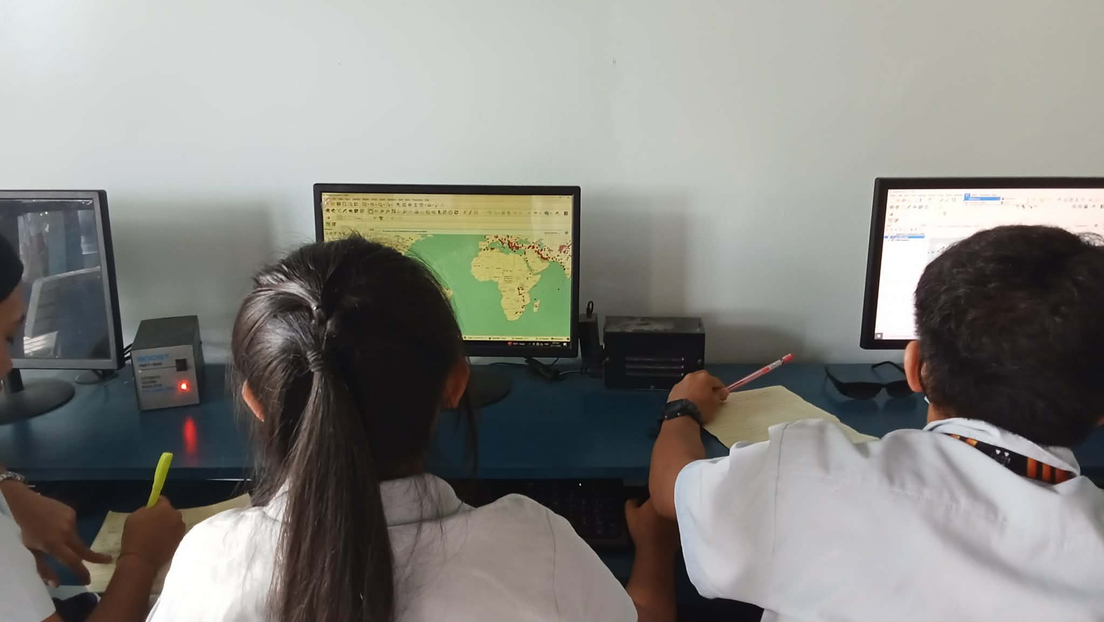
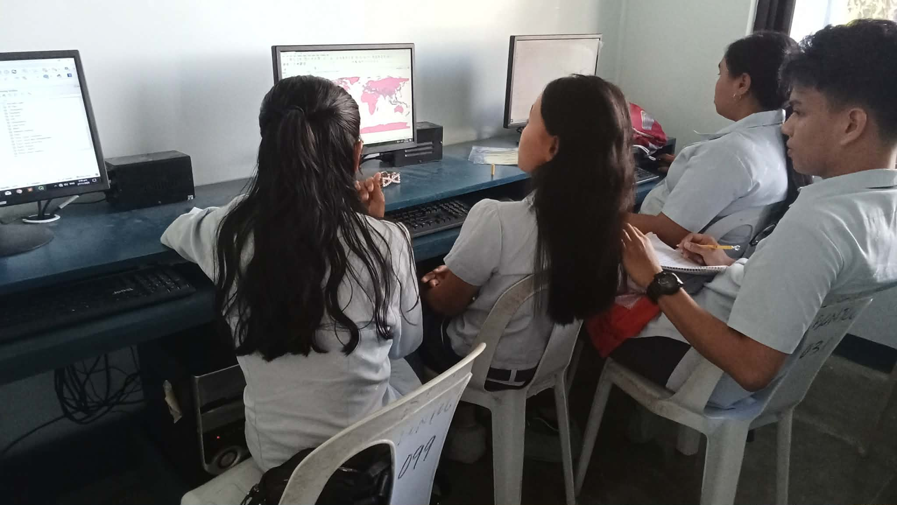

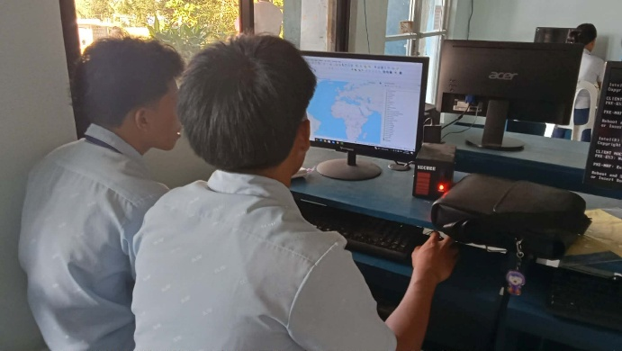
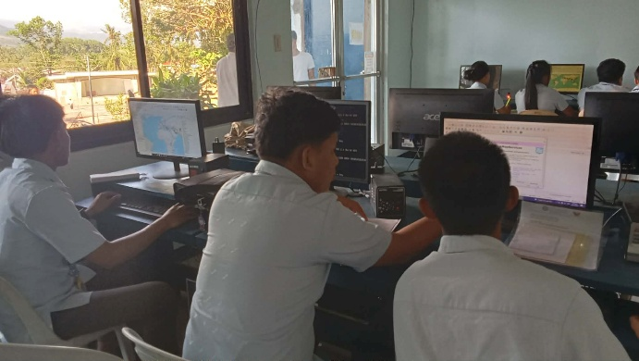
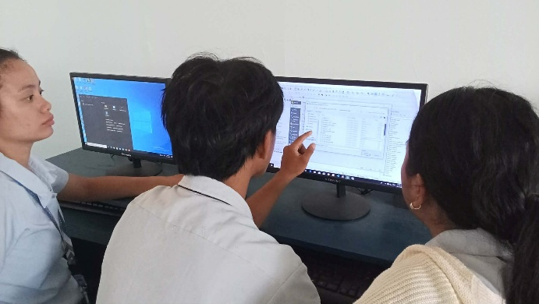

Prepared by: Approved:

JUNNIE RYH M. SUMACOT SHERWIN G. CADAY, PhD.
Instructor Program Chair

